Worked example
Sativa_hydroponics example

Import spectra for whole scan
Let’s extra all spectra for Sativa_hydroponics– scan00088 for Xspress3_mini_189. Start with menu: FileImport Spectra in the Spectrum Display window. Select device “Petra III P06 map Nexus HDF5 file”, which is perhaps misleading as it has lots of Nexus files. Navigate to the data and select all 18 scans for xspress3_mini_189.

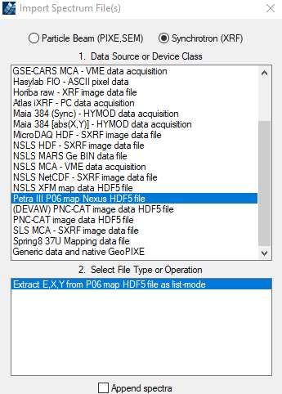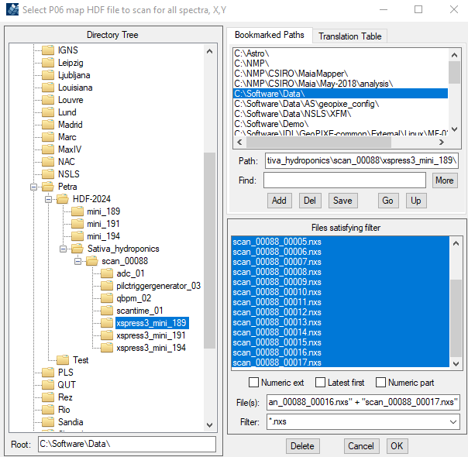

Select the output path …

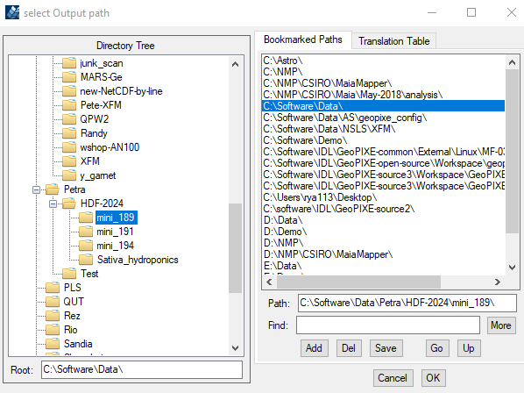

In the flux popup, select a suitable flux PV (variable) (e.g. “adc_01/value1”). The Preamp settings are ignored for now until we work out how the gain is specified. Leave the “Conversion” factor at 1 for now. If the top droplist shows “None”, you might need to click on “Scan data for PVs”. On “OK” a progress bar will show as the 18 files are processed. Spectra for all detectors will be shown overlaid together (green in this case), as well as projections of the image data onto X and Y axes (red, violet).

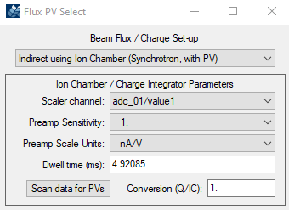

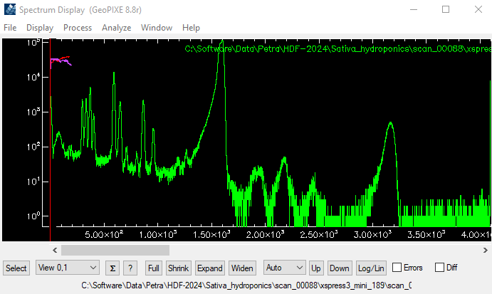

Spectrum fitting
Now let’s try and fit this. First, let’s delete the X,Y spectra. Open the Spectrum Select window (“Select” button) and click on “Delete:” (with “all XY and T” shown to its right on the droplist.

I didn’t really know what it was, so I made some guesses (e.g. it looked “bio”). Started by finding the beam energy, which was shown in the NXS files, and now can be seen in the Spectrum History window (menu: “WindowsSpectrum Properties and History”). It shows beam energy was 16 keV.

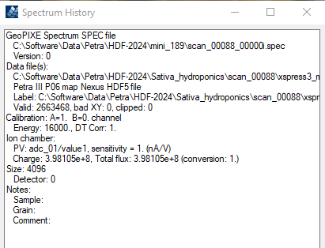

So, we know the energy of the scatter peak (16 keV) and its pileup (32 keV). This is a starting point. Use the Energy Cal window (menu: “DisplayCalibrate Energy”). This switches to the Cal markers. Set the two Cal markers by first clicking to set the RIGHT one. Then click way left in the spectrum to set LEFT and drag it into position. Now, for fast SDD signals it is likely that the pileup peak has a small deficit, so let’s put the Right cal marker (C1) skewed a little higher. Click on “KeV”, for keV units, and then “Apply: One”.

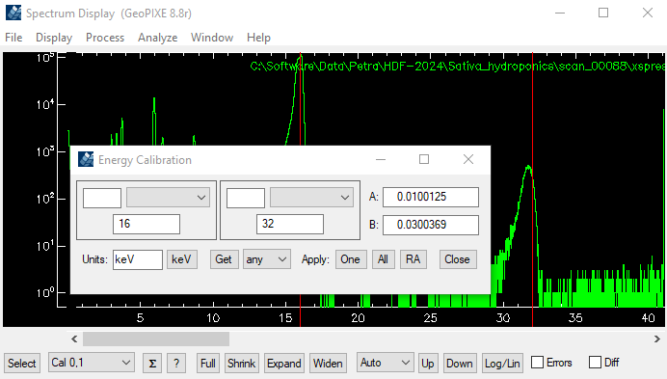

If you open the Line identification window (“?” button), this will switch to the “Identify” marker. If you click and drag in the window, it will show it’s energy and best match in the Xray Lines list. The main peaks show up at about 6 and 8.7 keV, so we might guess these are Mn and Zn. Let’s refine the Cal by putting the markers (use the droplist on the left to select “Cal 0,1” markers) on Mn Ka (C0) and the scatter peak (C1), after “Expand” to zoom in …

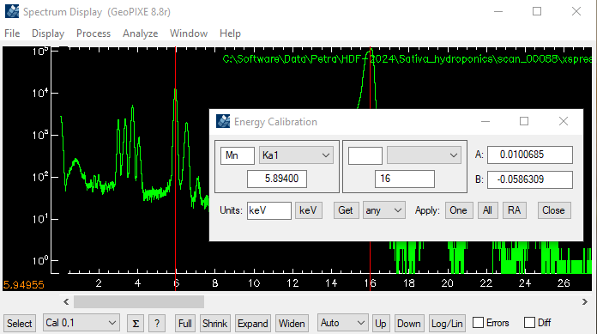

Return to the Identify marker (either use left droplist or click anywhere in the Identify window). Drag the marker around to look at line energies. It seems that we have Ar, K and Ca, which are all expected in a bio sample in air. Now save the spectrum into a top-level sub-dir for mini_189 (don’t put these down in the NXS dirs) …

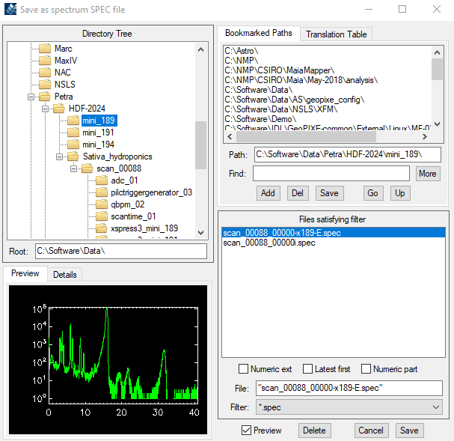

Now open Xray Spectrum Fit window (menu: “WindowsXray Spectrum Fit”). I realize that I used a Maia detector earlier. Let’s select a SDD detector (e.g. “APS Vortex SDD”) and for air path for X-rays let’s choose something reasonable (e.g. “Air 5 mm”). Now open the PIXE/SXRF Yield calculation window by clicking on “New”. Set reasonable parameters here for your detector. I chose detector at 90 degrees with target rotated to 45 degrees. Click on “?” in the detector area to see a popup showing the geometry. Does it look OK? For a sample I chose a thin tissue sample composition.

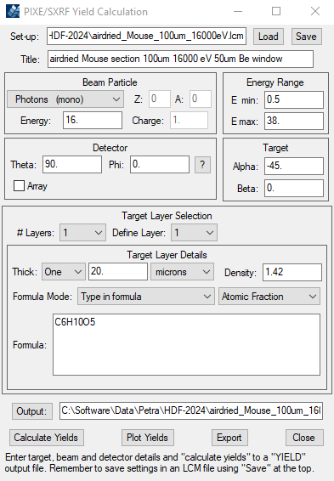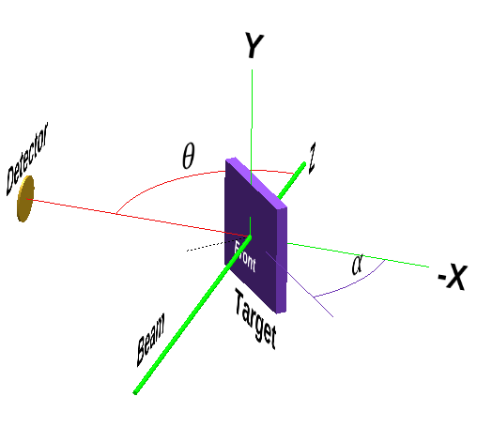

Click on “Calculate Yields” and select a filename are put it in the top-level dir.

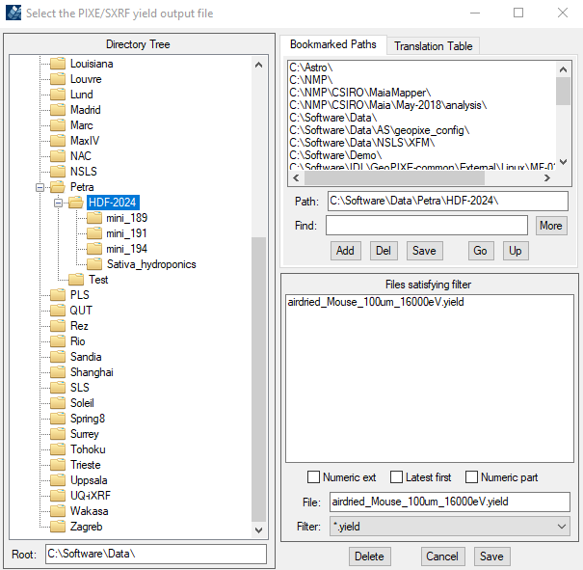

Now, back in Xray Spectrum Fit, select the elements Ar, K, Ca, Mn, Zn. Set the Energy Range to 1.5 to 30 keV. Disable “Tail” fitting and click “Fit: One”. Now the Compton tail has probably skewed p3eak widths, so lets zoom in on just the lines by Using the “View” markers and setting them to 1.5 keV and about 14 keV. Click on “Use View” and Fit again. That fit should be better. It shows some missing elements (Si, Fe, Cu, Br, Kr). Add these. There might be some Br (on Mn Ka + Ka pileup peak at about 11.8 keV). The fit is much better …

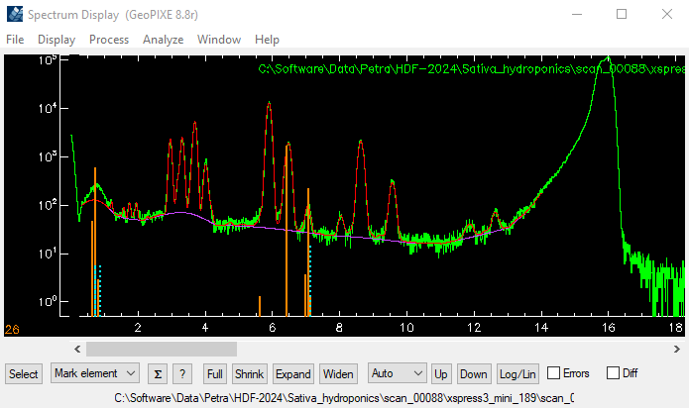

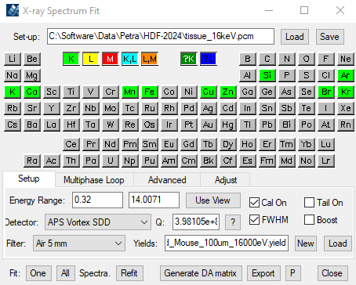

Save the fit somewhere “Tissue_16keV.pcm”. Now we need to refine the fit to the scatter peaks. First switch off fitting “Cal On” and “FWHM” (peak widths) using check boxes. Widen the View marker range to about 1.4 to 28 keV (to include Pileup peaks) and click “Fit”. The energy cal remain fixed as before, but we now fit across the scatter peaks, which look a bit poor.

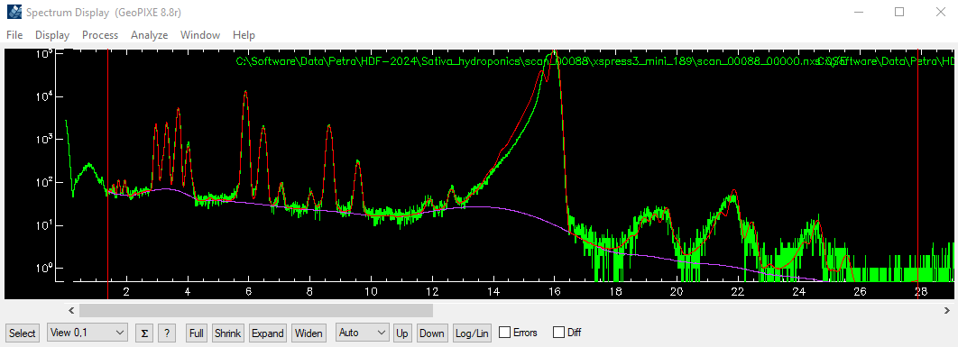

Go to the “Advanced/XRF” tab. We’ll adjust “Shift” which moves the Compton peak around (2 clicks on left arrow moves it right to a better energy). Now adjust the tail strength (“Comp Tail”) and its length (“Tail Len”). Tail=0.35, Len=1.25 starts to look better. Click “Fit” to see how that fits. OK, perhaps a bit less Tail=0.10 is better after “Fit”. A final tweak of Shift to -0.02 and “Fit” looks pretty good. Save the PCM file again.

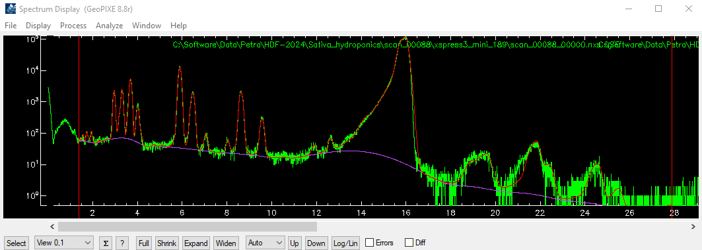

Now let’s look at concentrations obtained by opening the “Fit Results” window. Clear previous fits and Fit again. The concs are tiny (~0.0000002 ppm). Go back to the main ”Setup” tab in the fit window, and click on “?” adjacent to “Q”. In the “Change to” field type 1.0e-9 and “OK”. This sets the flux calibration factor “conv”. Now fit again … These may be reasonable concs …

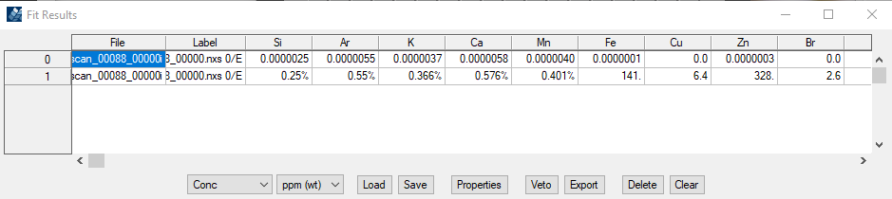

Now save the spectrum again (with its fit overlay, refined energy cal and updated “conv” value).

The DA matrix and imaging
Now click on “Generate DA matrix” to make a DA matrix file (simple “Single” DA matrix). Save that in the top dir.

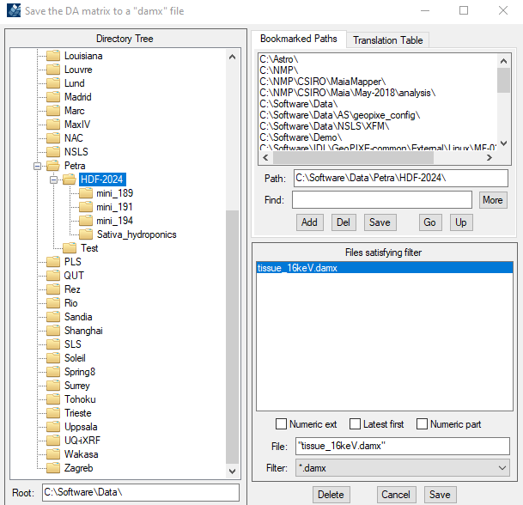

Now turn your attention to the “Sort EVT” window to generate images. Files tab: select First NXS file (from Xspress3_mini_189 dir). Last can be left blank (means do all). Scan tab: nothing to set. Flux tab: set it up like this and click “Get” to load the saved fitted energy spectrum to provide the energy calibration to use), DA tab: load the DA matrix file …

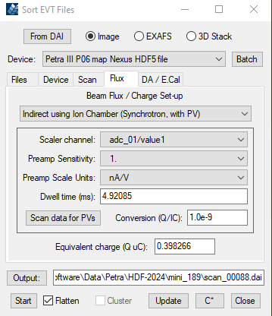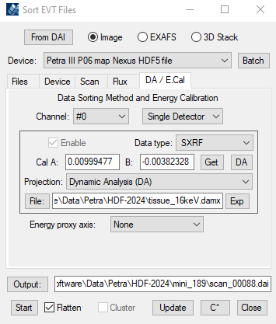

Select an output file and dir, top level/mini_189 dir. Now click “Start” … To view all elements use the menu (main Image window): “DisplayMulti Image”).

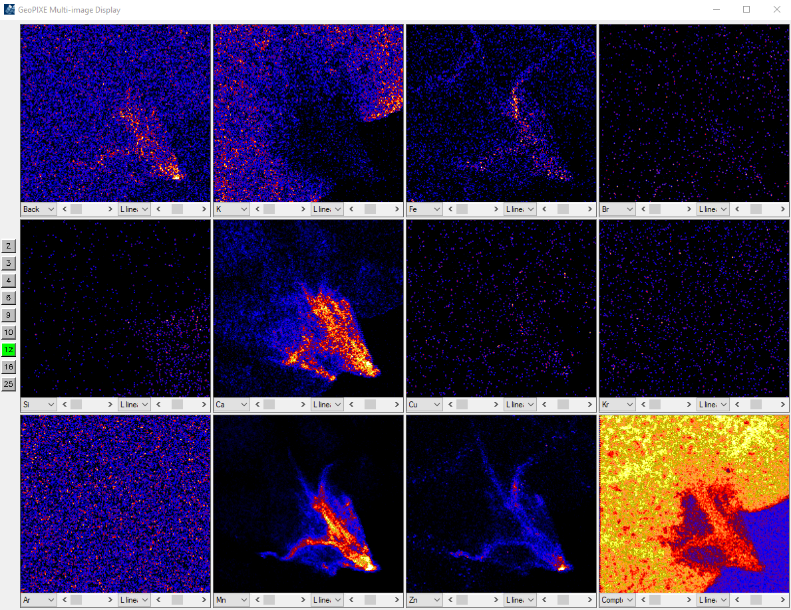

Drag the Mn image larger and select “Box” as the marker type from the droplist. Now click and drag out a box over the entire area and click the “Σ” button (may revert to “S” under Linux). In the Image Regions window we see similar concentrations as in the fit above, which is reassuring …

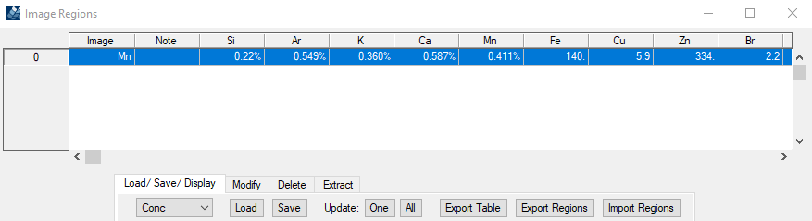

Now you can explore the image data …

